Here is the same code assembled using the EDASM assembler from Apple.
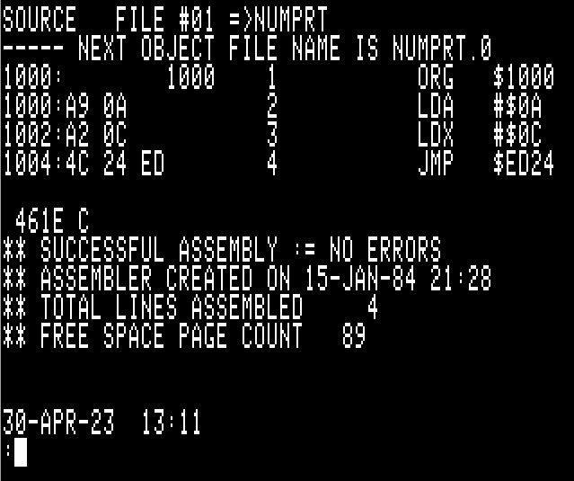
Here it is being executed via the ‘BRUN’ command…

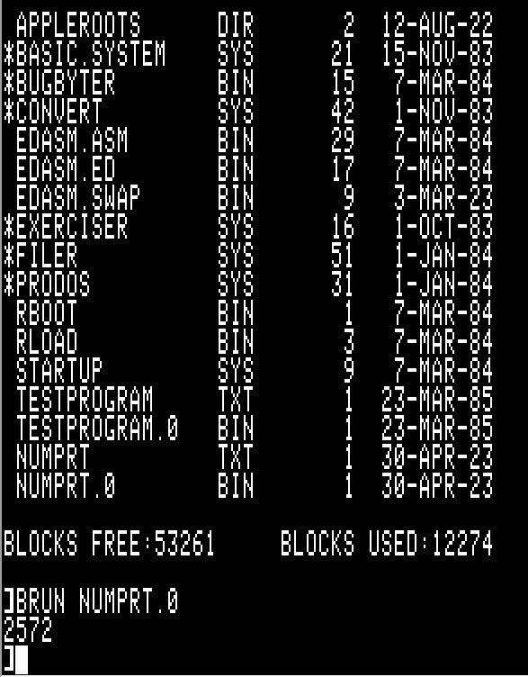
Here it is again being assembled and run via ORCA v4.1

