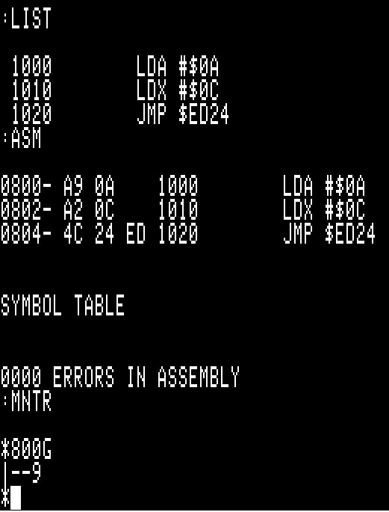
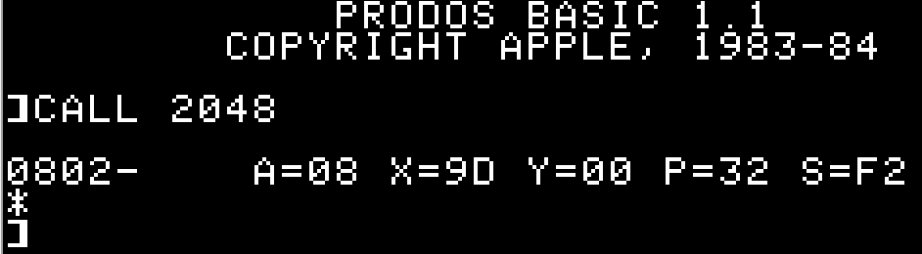
As can be seen above, entering the monitor from the S-C assembler then using the ‘go’ command results in the same anomalous results.
‘Calling’ the code example from BASIC seems to fail because it does not seem possible to load or execute S-C assembler files outside of the S-C assembler environment. The designer of the S-C assembler made a number of changes to the normal ProDOS/BASIC code to allow his assembler access to commands like ‘LOAD’ and ‘SAVE’ to recognize the S-C assembler proprietary file format. While this is helpful ‘inside’ of the S-C assembler environment to load and save such proprietary files, I do not understand how to load or save such files outside of the S-C assembler environment as neither the normal BASIC ‘load’ or ‘save’ files ‘understand’ the S-C assembler files, nor do the ‘brun’ or ‘bsave’ command work.
All of these examples are running under AppleWin v1.30.14 using the ‘Enhanced Apple //e’ model.
