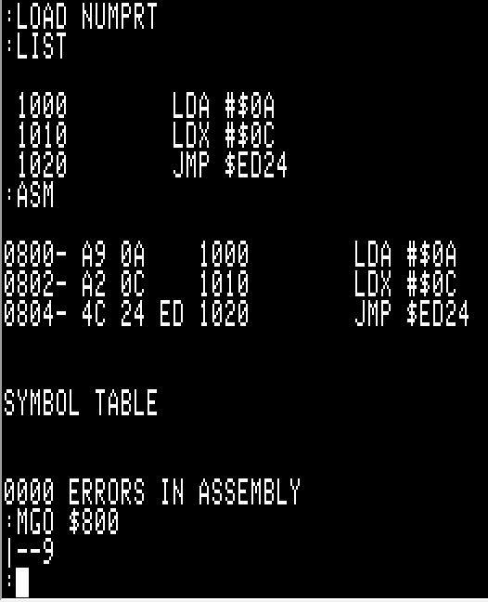
The above three lines are supposed to print the 16-bit decimal equivalent of the hex values stored in the accumulator and x register.
While the book ‘What’s Where in the Apple’ states that the low byte to be used by the LINPRT ($ED24) kernal function is to be found in the accumulator while the high byte to be used is to be found in the x register, running the above code in the Merlin assembler results in the number ‘2572’ being printed to the screen. This is the opposite of what is stated in the above-cited book.
That’s one point of confusion, the other is trying to understand that while the Merlin assembler provides a predictable result (aside from the juxtapositioning of the high/low byte in the accumulator/x register in terms of how the LINPRT function interprets the values in those registers), why does Merlin print the correct result while the S-C Macro Assembler v2.0 prints “|--9” instead of 2572.
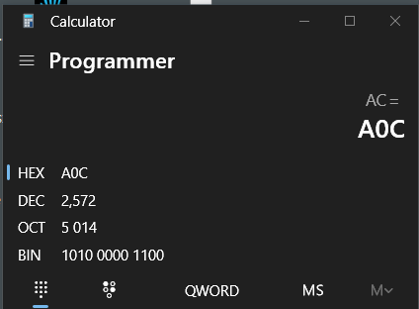

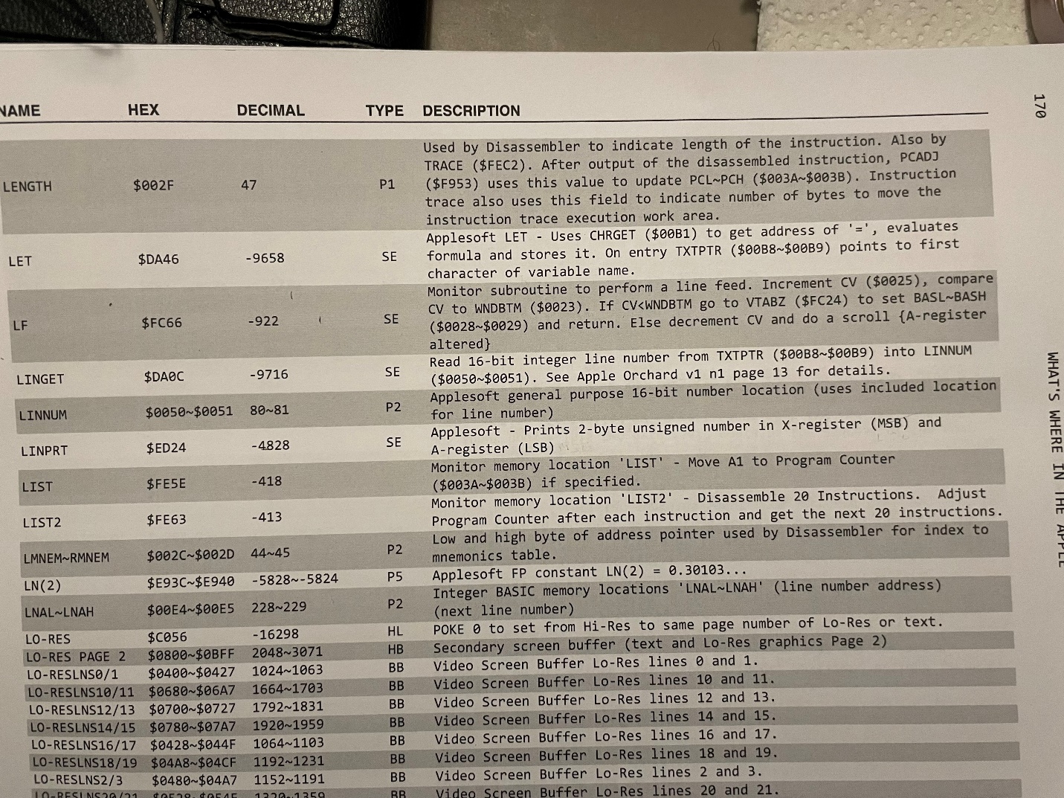
Assembling the same three lines within Merlin and typing ‘BRUN NUMPRT’ from the AppleSoft prompt results in the following…
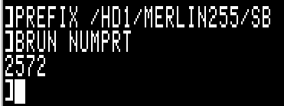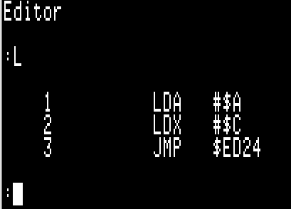

The anomalous result when executing these three lines within the S-C Macro Assembler v2.0 via its internal ‘MGO’ command may be a contributing factor. I do not yet understand exactly how to execute a program developed within the S-C Macro Assembler in any way other than using its ‘MGO’ command.
Any help in understanding this is appreciated.

